 | Faculty of Natural and Applied Sciences  Computer Science Department
CSC 323: Object-Oriented Design
Project – Report
Submitted by:
Student ID | Name | Major
20231576  20230866  20231325 | Edward El Ghazal  Giorgio Khoury  Nicolas Assaad | Computer Science  Computer Science  Computer Science

Project Description (around 500 words)
In today’s fast-paced world, food delivery systems bridge the gap between restaurants and customers, offering convenience and efficiency. Our Online Food Delivery System is a C# based application designed to simplify ordering, payment, and delivery tracking while sticking to strong object-oriented design principles. This description explores the system’s architecture, key features, and the design philosophies that ensure flexibility, scalability, and maintainability.
The platform enables customers to browse menus, place orders. Built on modular design principles, the system decouples components like payment processing, notifications, and delivery logistics, ensuring each part operates independently yet cohesively.
At its core, the system prioritizes user experience. The User class serves as a base for Customer subclass, inheriting shared properties like Name and Contact. Customers customize profiles, save addresses, and set notification preferences. This hierarchy ensures code reusability and logical separation of responsibilities.
Menus are organized into categories using the Menu and MenuItem classes. Customers browse dishes and add items to a virtual Cart. The cart dynamically calculates the total amount using foreach loops to iterate through items.
The Facade pattern shines in the OrderProcessorFacade class, which acts as a unified interface for complex workflows. When a customer places an order, the facade coordinates cart validation, payment processing, and notifications abstracting subsystem complexities. To ensure consistency, the facade also employs the Singleton pattern, guaranteeing only one instance manages all orders. This prevents conflicts, such as duplicate charges or missed notifications.
Payment flexibility is achieved through the Payment class, which supports cash and card. Post-payment, the INOTIFICATION interface triggers alerts via email or SMS. Concrete classes like EmailNotification override SendNotification(), ensuring customers receive an email/SMS confirming the placement of their order.
The IDeliveryStrategy interface defines a strategy for delivering an order, allowing different delivery methods to be used interchangeably. The Order class has a property of type IDeliveryStrategy, which enables it to delegate the delivery process to a specific strategy, such as StandardDelivery or ExpressDelivery. This setup follows the Strategy Pattern, promoting flexibility and adherence to the Open/Closed Principle, as new delivery methods can be added without modifying the Order class.

Class Diagram (UML)
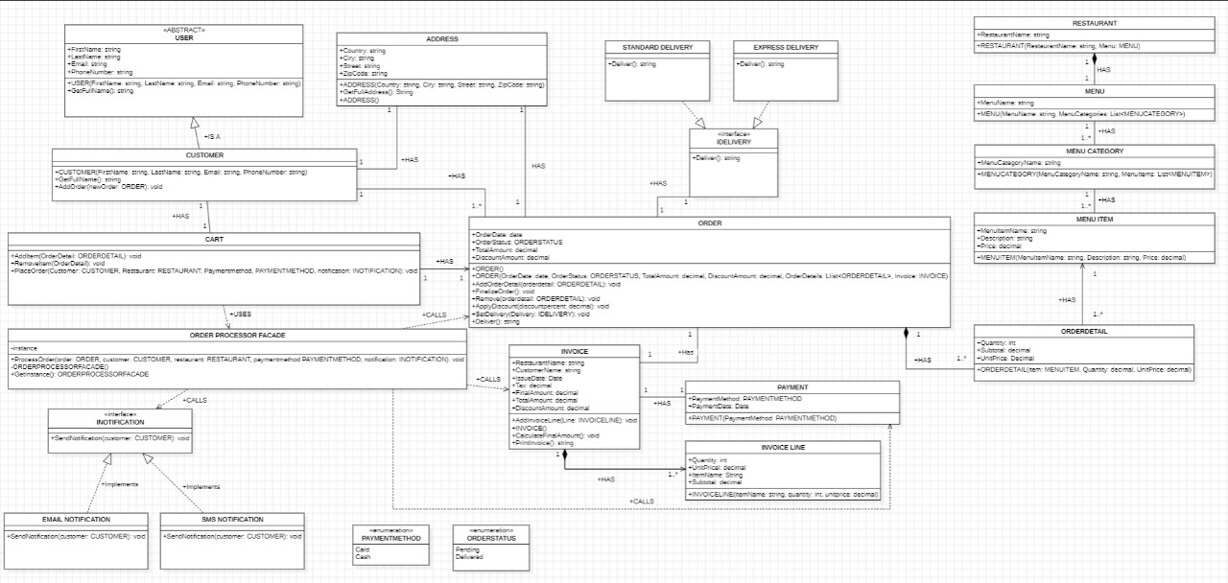

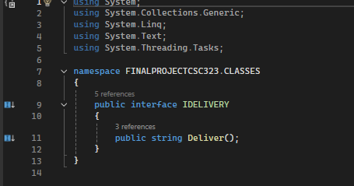
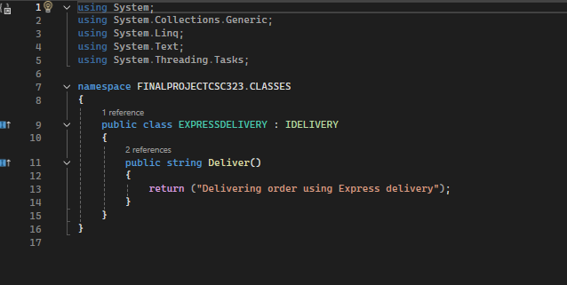

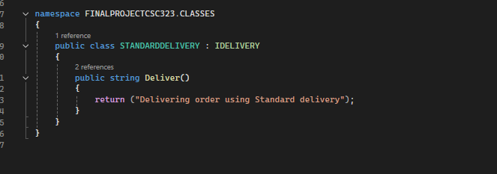
Figure 2. The interface Idelivery and it’s inheriting classes.

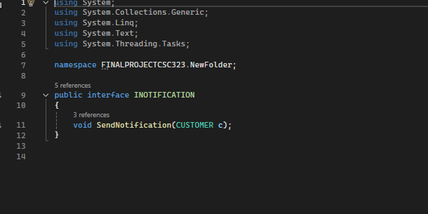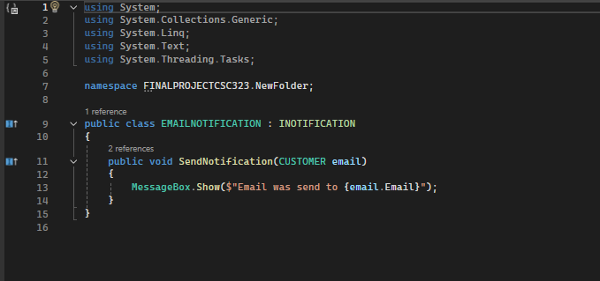
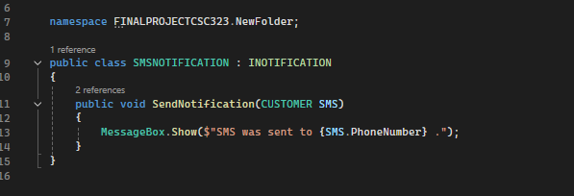
Figure 3. The interface Inotification and it’s inheriting classes.
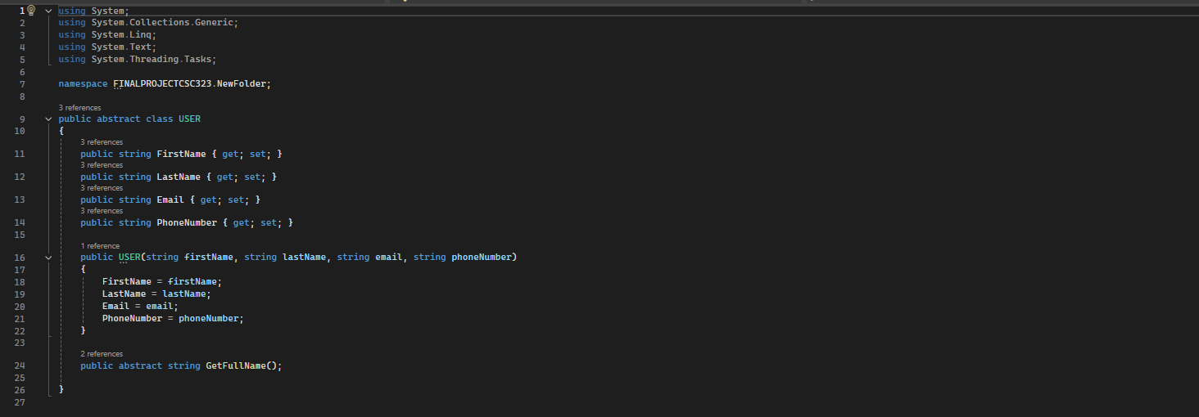
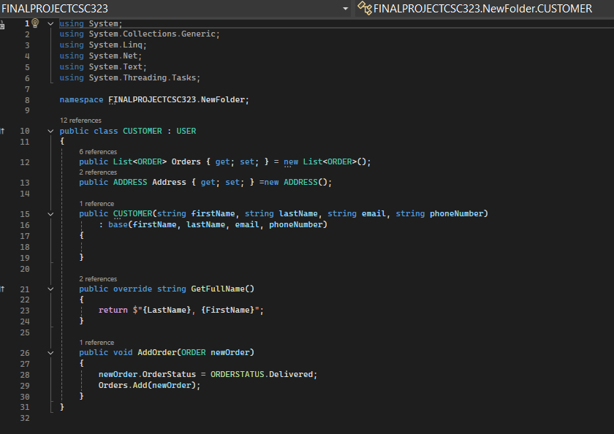

Figure 4. User and it’s inheriting class.

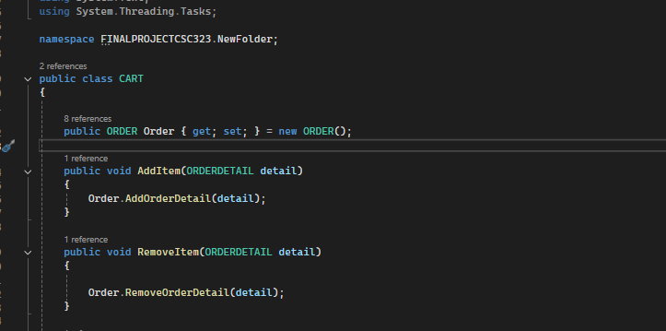
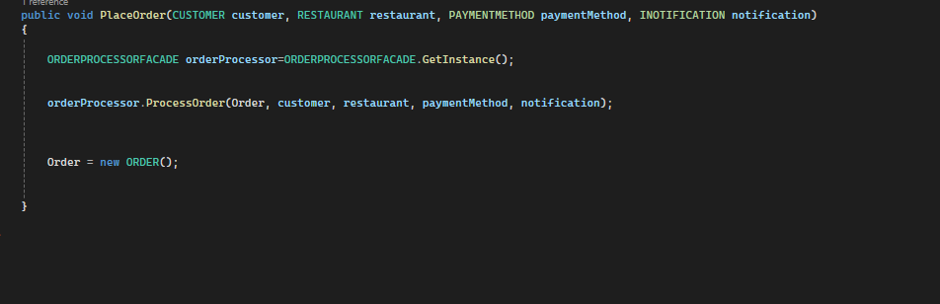
Figure 5. The class Cart.

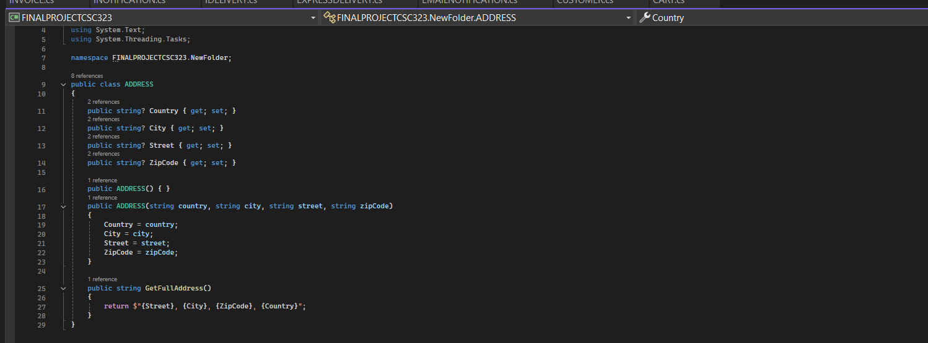
Figure 6. The class Address.

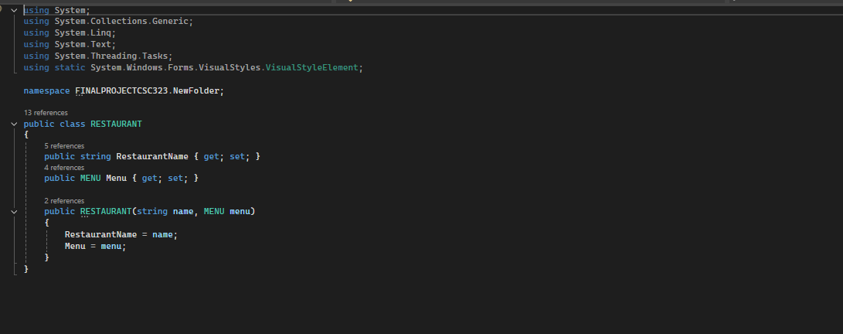
Figure 7. The class Restaurant .

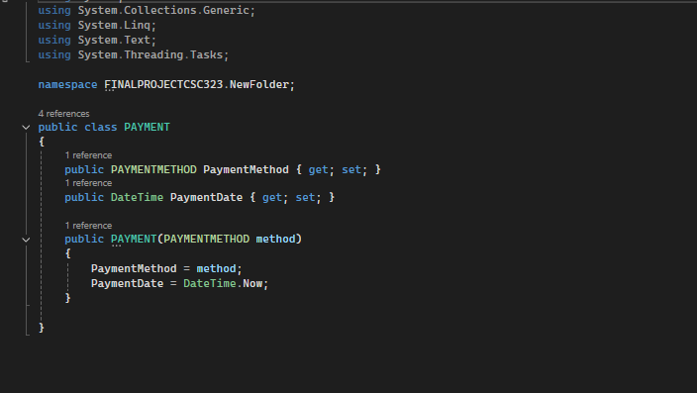

Figure 8. The class Payment.

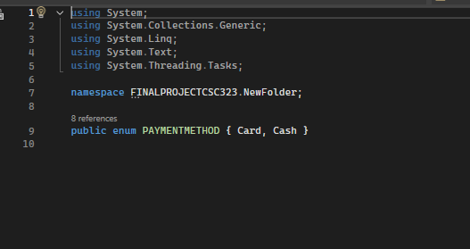

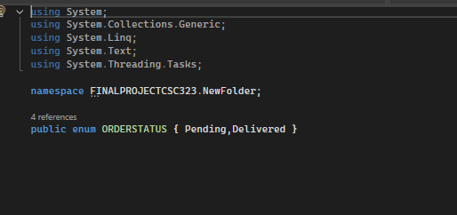
Figure 9. The Enums for Payment Method and Order Status.
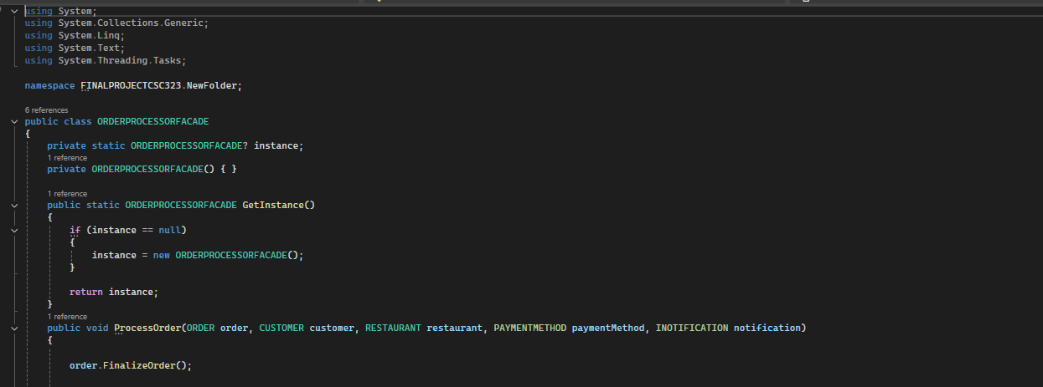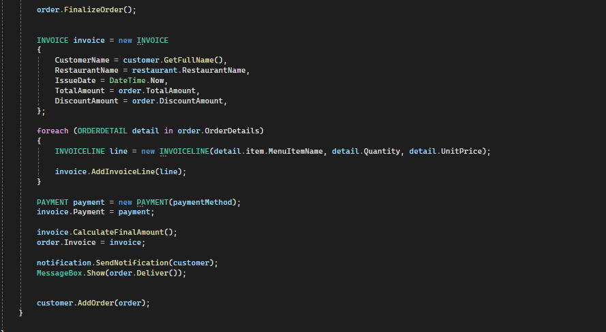
Figure 10. Order Processor Façade .
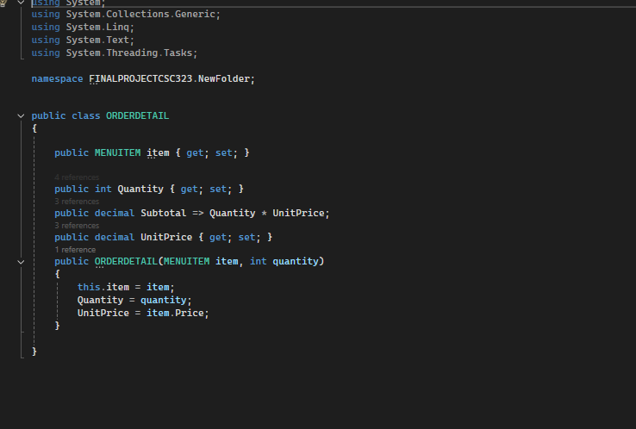

Figure 11. The class Order Detail.
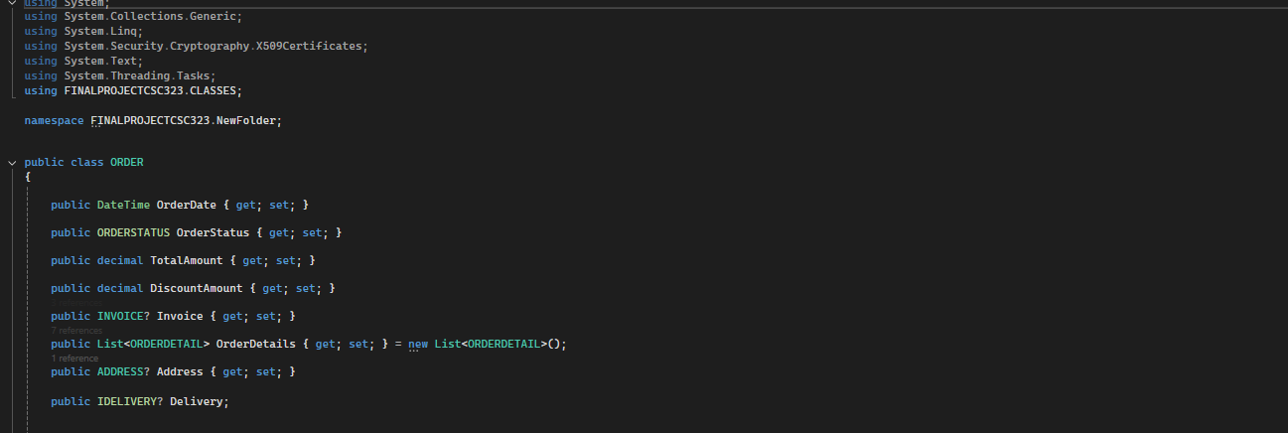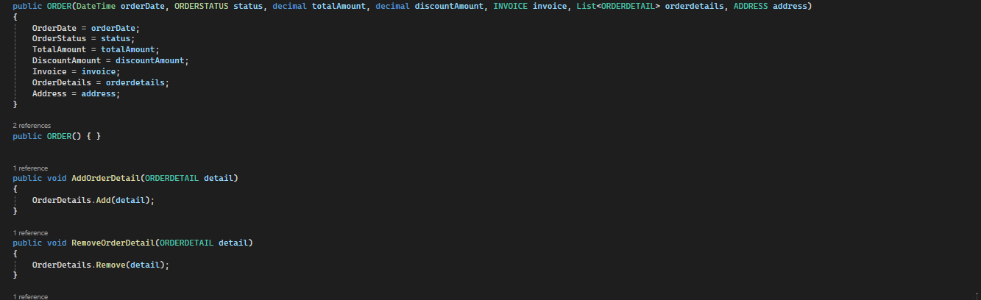
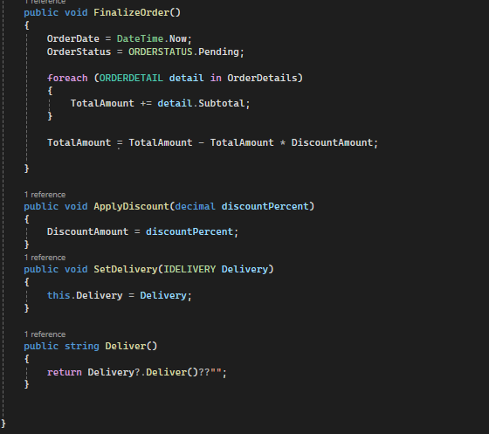
Figure 12. The Class Order.
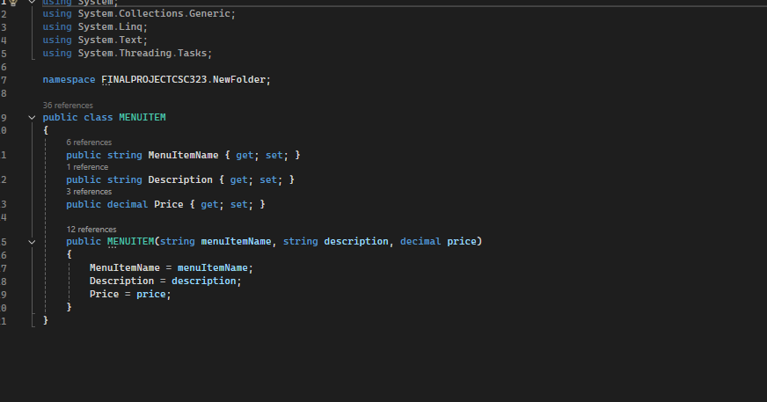

Figure 13. The Class Menu Item
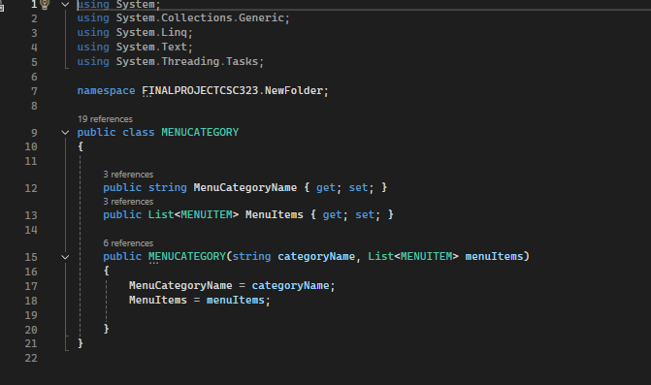
Figure 14. The Class Menu Category

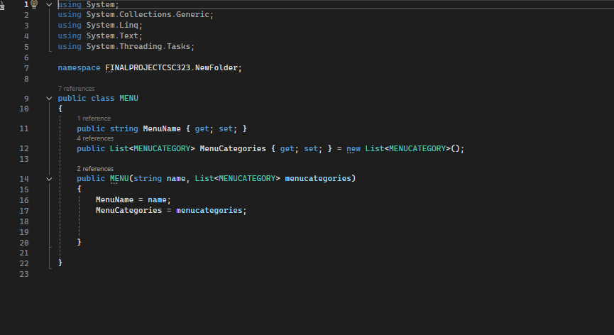
Figure 15. The Class Menu
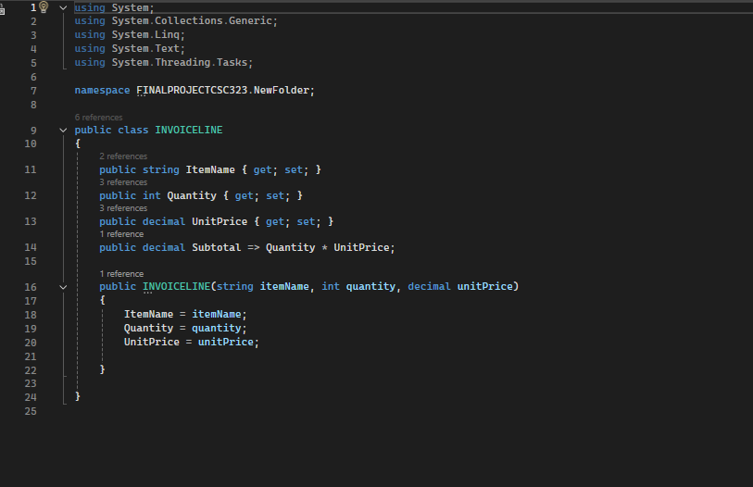
Figure 16. The Class Invoice Line
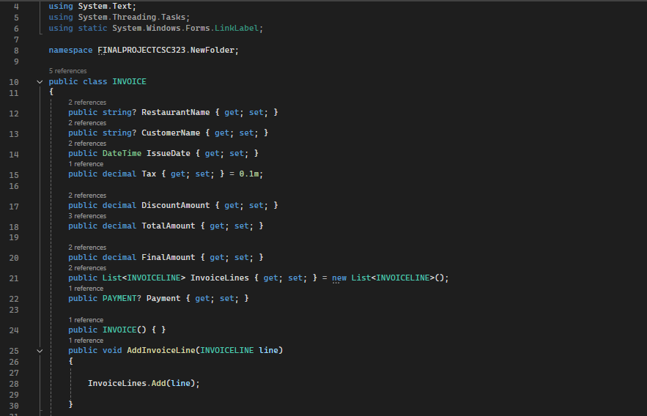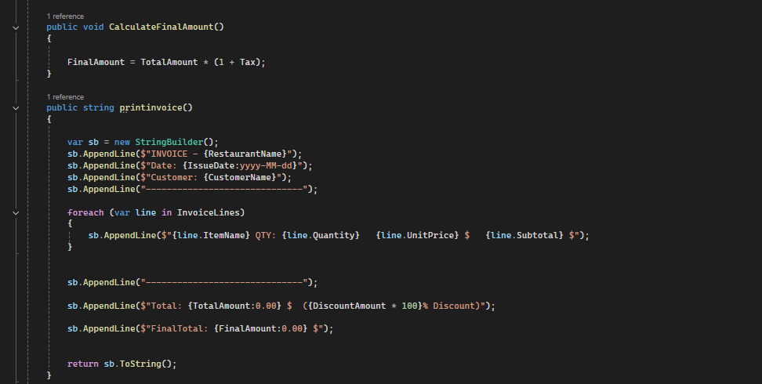.
Figure 17. The class Invoice

Descriptions of how and where you have used key concepts
Concept | Description (around 30 words each)  refer to the class diagram and source code figures as you see fit
Abstraction (abstract classes and/or interfaces) | We have used abstract classes and interfaces for many things among them, the INOTIFICATION interface defines a contract for classes to implement notification functionality.
Concrete classes | One of the concrete classes used is the Customer class which is inherited from the base class User and adds some special functionality.
Namespaces | Our project is divided into two namespaces, one for the classes and one for the form. Each organized based on their specific roles and responsibilities ensuring a clean separation of concerns.
Methods | Methods encapsulate actions in the system. For example, PlaceOrder() in OrderFacade manages order processing, and AddItem() in Cart adds a menu item to the user's cart.
Properties | Properties define the attributes of classes. For instance, Customer has properties like FirstName, Email, and Address, which store essential information used throughout the ordering and notification processes.
Overriding of methods and/or properties | The Email Notification class overrides SendNotification() from INOTIFICATION, while Customer overrides GetFullName() from USER.
Constructor overloading | The ORDER class has an overloaded constructor. One default constructor, and another constructor that takes parameters to fill the attributes.
Enumeration (Enum) | Payment Method (Cash, Card) and Order Status (Pending, Delivered) are the Enums that we used in the code.
Collections (e.g., Lists) | Menu uses List MenuCategory to manage dishes, Order stores List OrderDetail for items and Invoice uses List InvoiceLines.
Loops (e.g., foreach) | We iterated over items with foreach to sum the prices of each product. We also used for loops to generate the invoice lines from the invoice details.

SOLID Principle | Description of where the principle is realized and for what purpose (around 50 Words)
1) Single Responsibility | The class USER handles only user related tasks, same as class CART that only takes care of adding and removing items. This keeps code clean and easy to fix.
2) Open-Closed | We added to the system new features like express delivery and standard delivery without changing the original code, which is the idelivery interface, so we extended the code instead of modifying it.
3) Liskov Substitution | Child classes should work like their parents. For example, we can interchange SMSNOTIFICATION and EMAILNOTIFICATION since both of them inherit from the same class and both of them depends on functions of the base class.
4) Interface Segregation | This approach allows the ORDERPROCESSORFACADE class to avoid including unnecessary methods, which is why we implemented the INOTIFICATION interface, to ensure it only depends on the functionality it actually uses.
5) Dependency Inversion | In the ProcessOrder(INOTIFICATION) function, the parameter is of type INOTIFICATION, allowing the method to work with any notification implementation, such as SMS or Email, demonstrating dependency inversion by relying on abstractions, not concrete classes.

GOF Design Pattern | Description of where the pattern is realized and for what purpose (around 50 Words)
1)Facade | The OrderProcessorFacade which finalizes the order, generates the invoice, changes the status of the order and sends a notification.
2)Singleton | The OrderProcessorFacade uses Singleton to ensure only one instance manages order workflows. This prevents conflicts and centralizes control.
3)Strategy | The IDelivery interface defines delivery methods. ExpressDelivery and StandardDelivery implement it, letting the Order class switch strategies.

User Interface (Windows Forms)
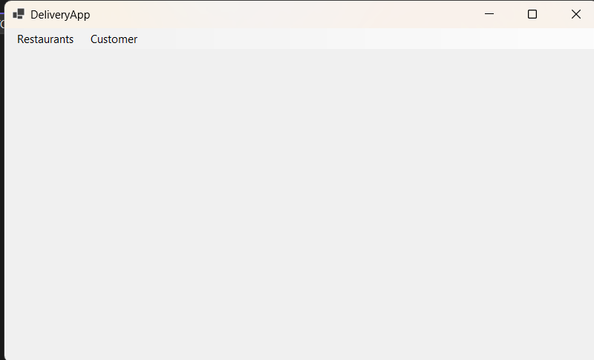
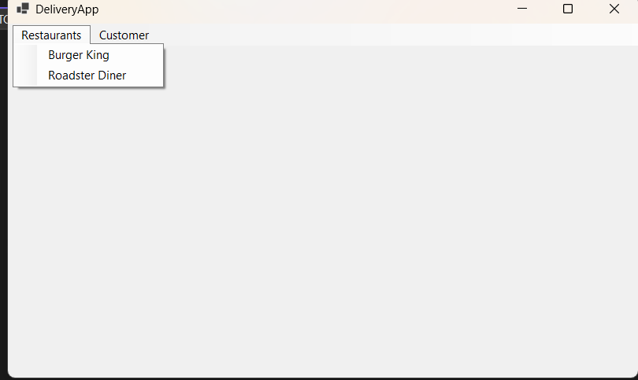
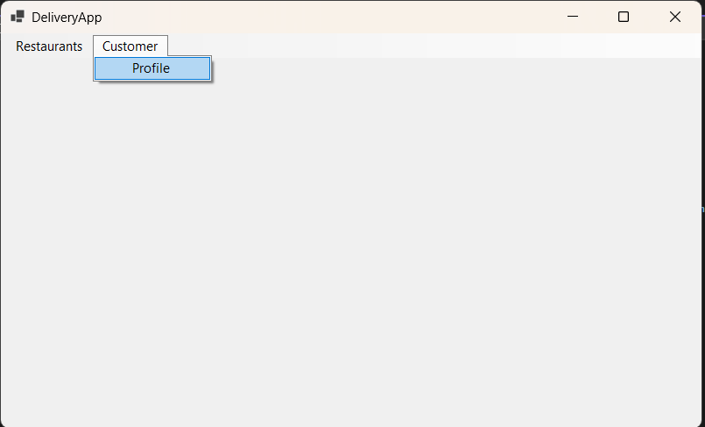
Figure 1. Main UI
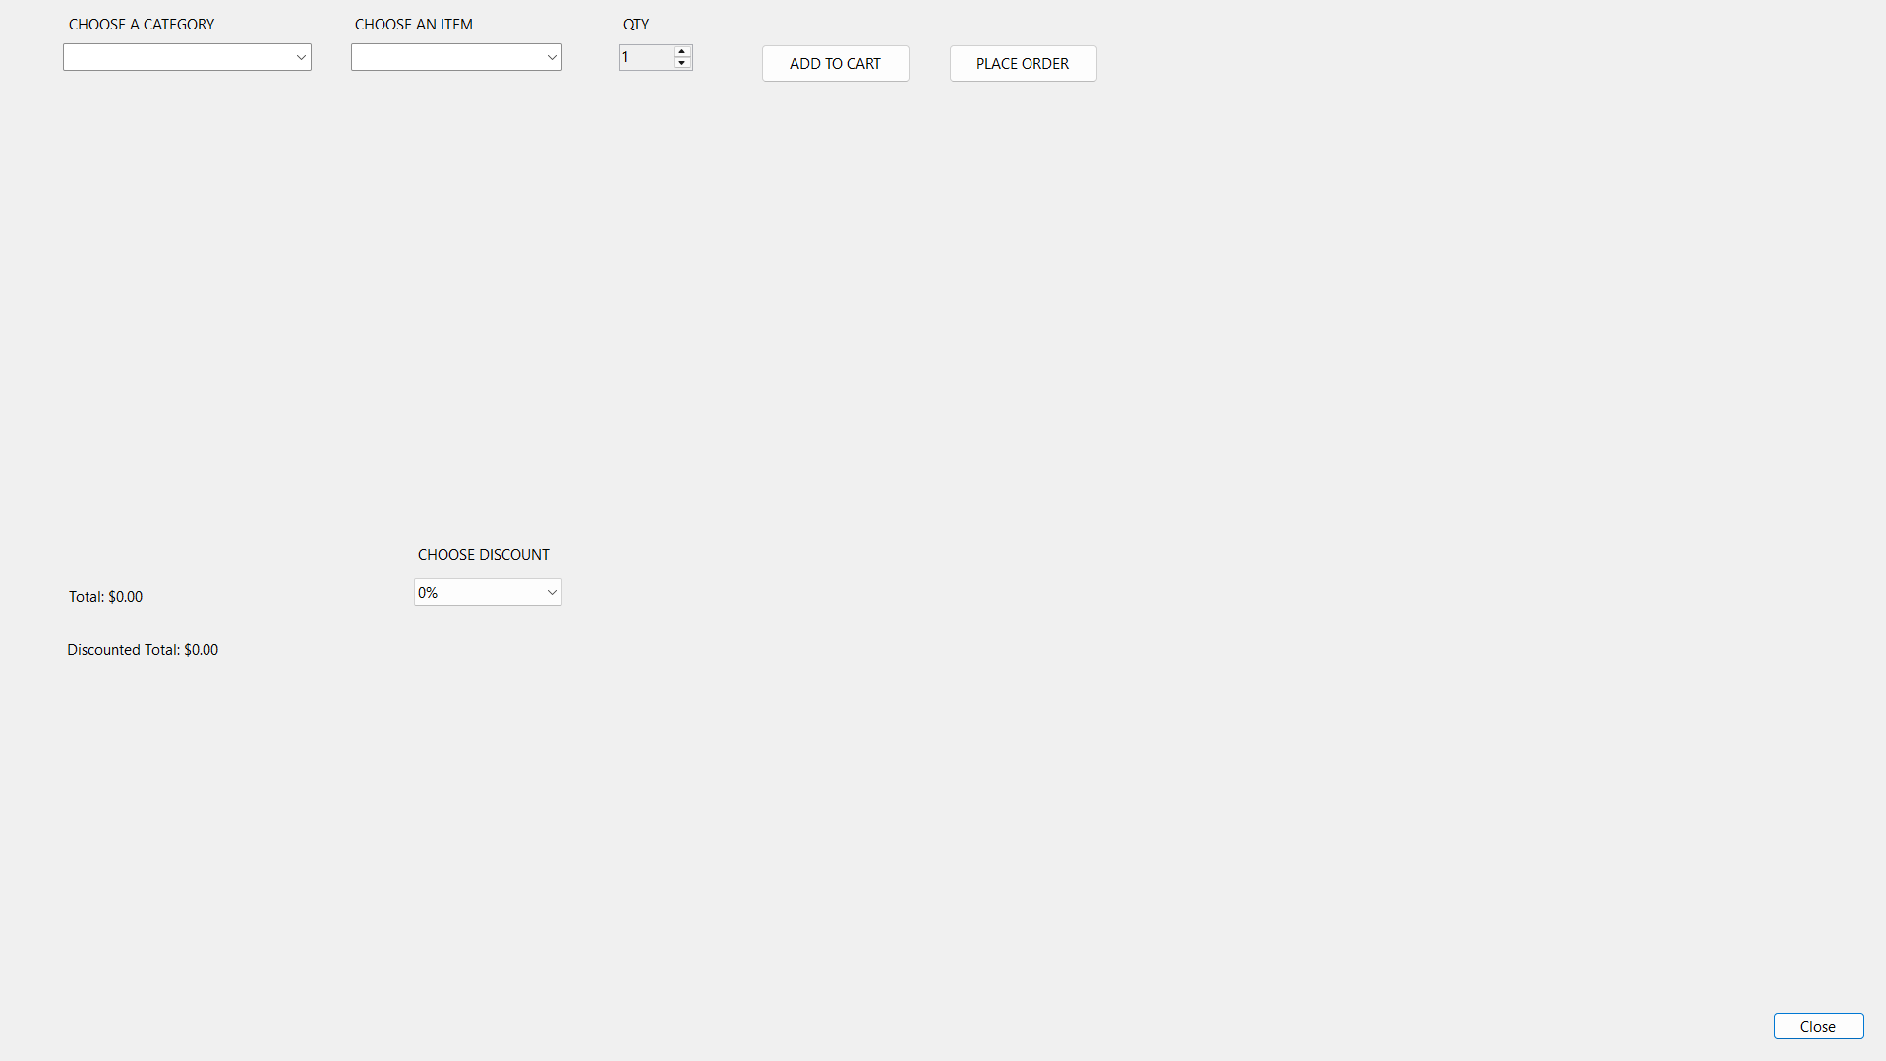
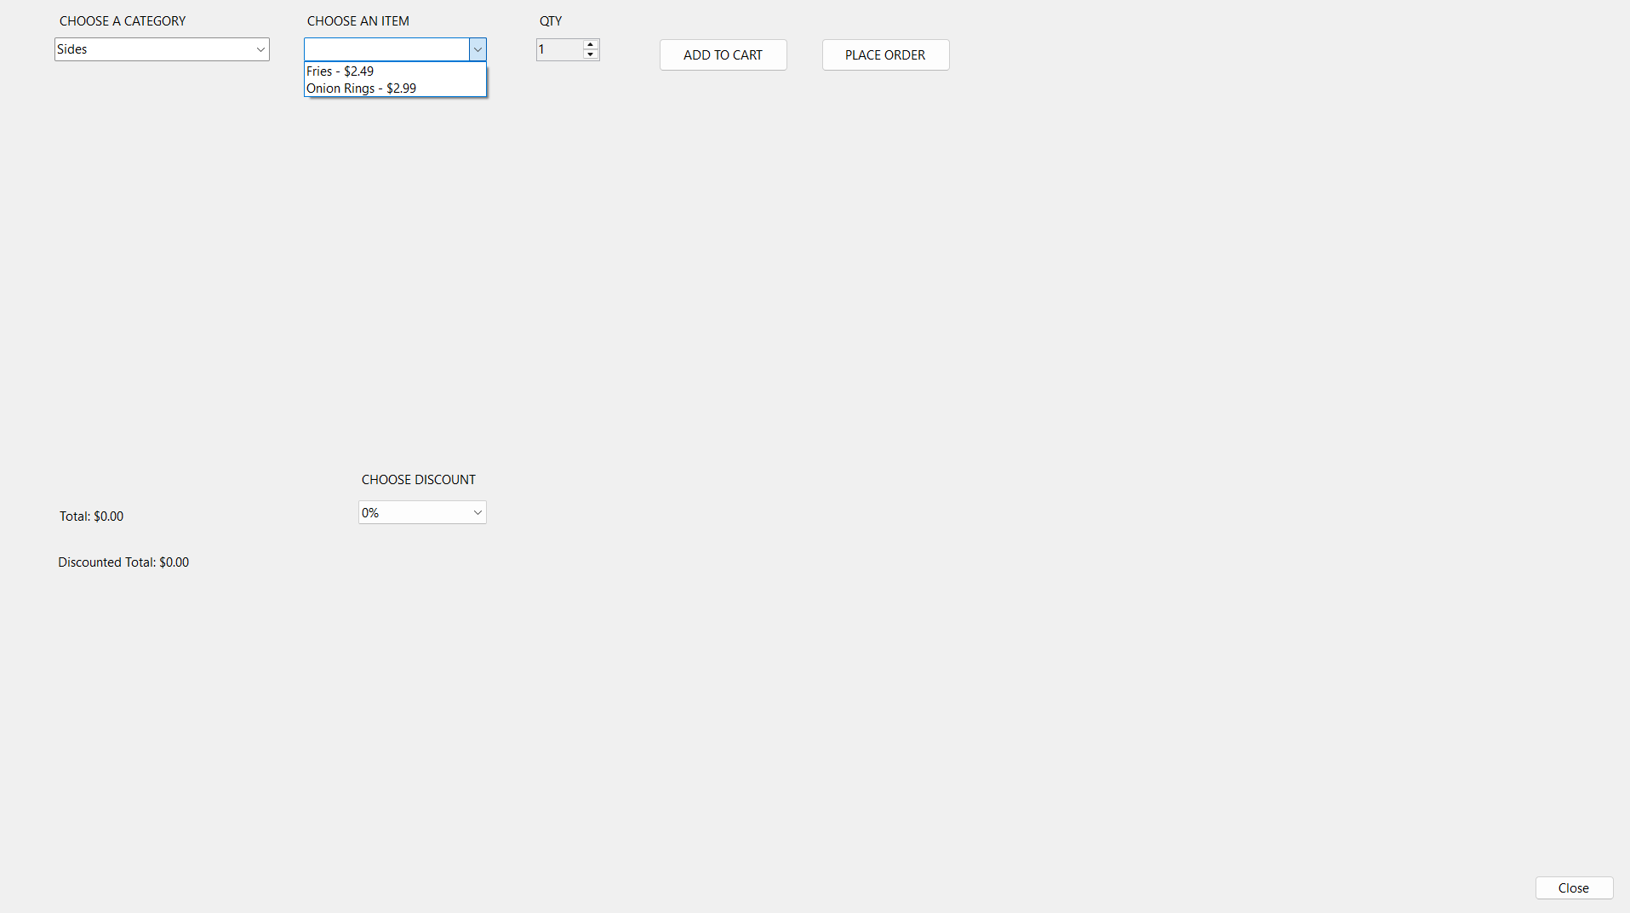
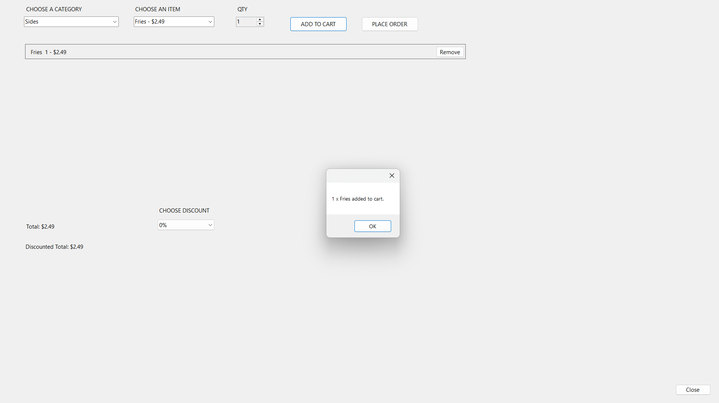

Figure 2. Create Order UI
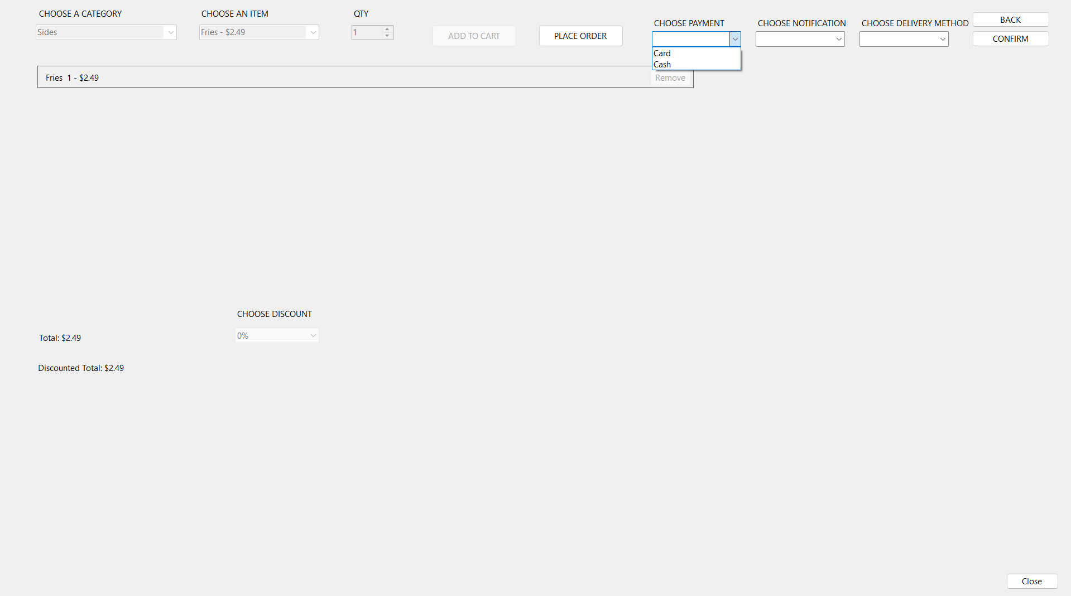
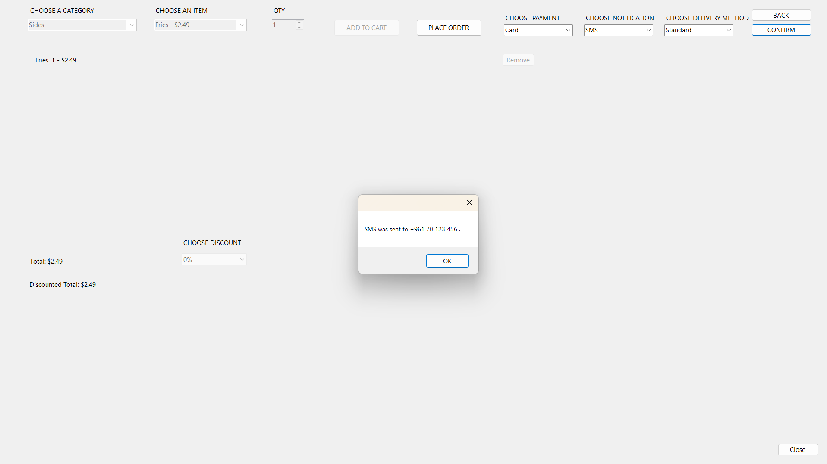
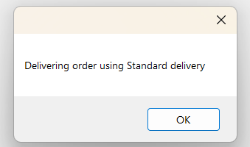
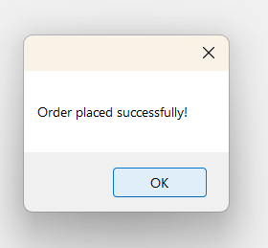
Figure 3. Order Confirmation UI
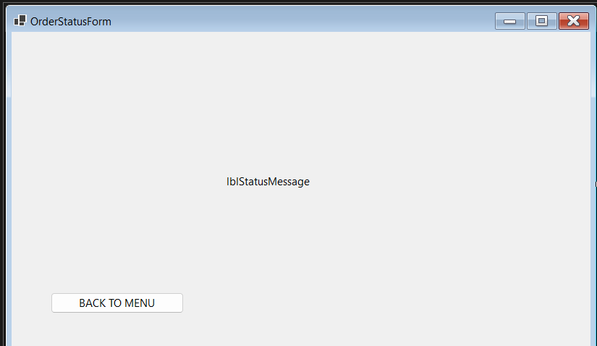
Figure 4. Order Status UI
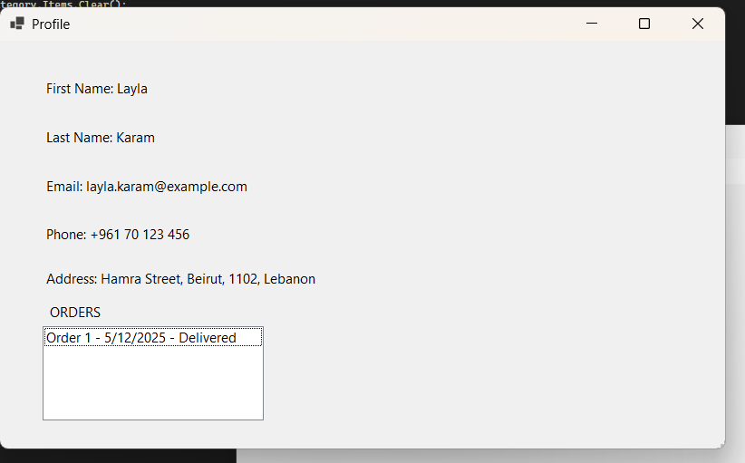
Figure 5. Profile UI
Brief Description of UI (around 50 words)
The Windows Forms UI allows users to browse restaurant menus , add items to a cart , track orders via notifications with their status, and pay with multiple methods, as well as a profile feature which saves previous orders and gives us few information about the Customer.

